CryptoverseCTF 2022

Sahil Bugade

(http://snip3r.me)

**Problem Statement:**

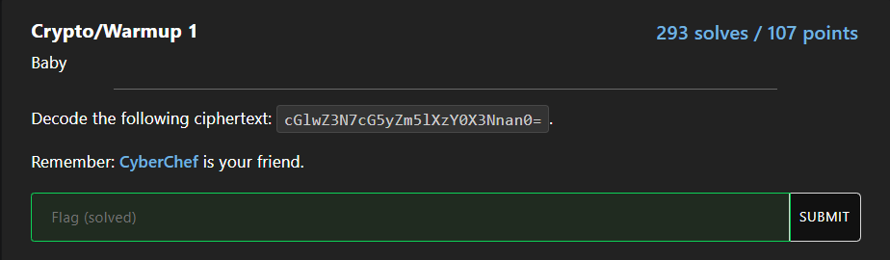

Given cipher text: cGlwZ3N7cG5yZm5lXzY0X3Nnan0=

Now after solving a bit of crypto CTFs we were easily able to guess that the given cipher text was encoded in base64. So firstly we decoded it from base64.

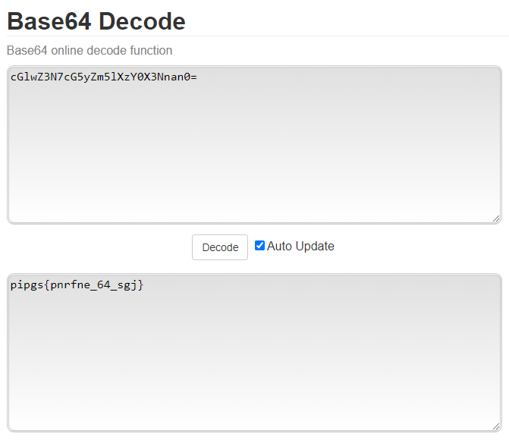

As you can see the decode text is “pipgs{pnrfne_64_sgj}” which can be identified as a format that a flag would be written in but isn’t the actual flag as the competition had its flag format “cvctf{}”.

So hereby, I saw that the output we got had (PiPgs) repeated “P” and the flag format (CvCtf) had “C” repeated. So I calculated how far is the alphabet “C” from “P” and came out to be 13 letters ahead.

So I calculated manually each and every alphabet 13 ahead of the given decoded form and came out with the flag cvctf{caesar_64_ftw}.

Later I came to know that such type of encryption is called ROT-13 encryption and could be found on the site: <https://www.dcode.fr/rot-13-cipher>.

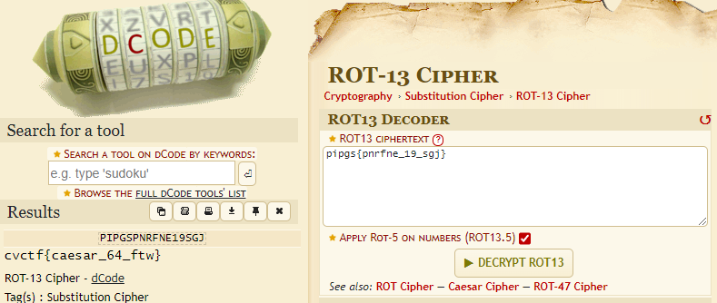

Flag: cvctf{caesar_64_ftw}

It was our first international CTF, so overall we enjoyed it and to mention teamwork is always a key to success!